To make the program db available in my SQL and connect it.

**SERVER HAS TO RUN WHILE USING THE PROGRAM!!!!**

3 Things to do to get the program running:

* Get the mySql java driver
* Import the scripts into own MySql instance
* Add own username and passwort to login file

Import from Project to my SQL:

Got to my SQL🡪server🡪data import🡪import from dump folder (DB-Scripts in projectfolder) file into the local mySQL server🡪click start import

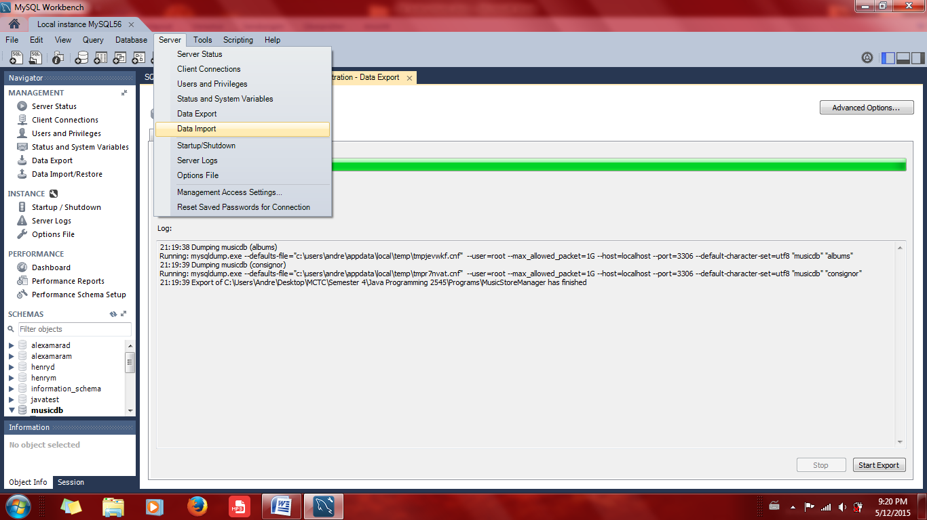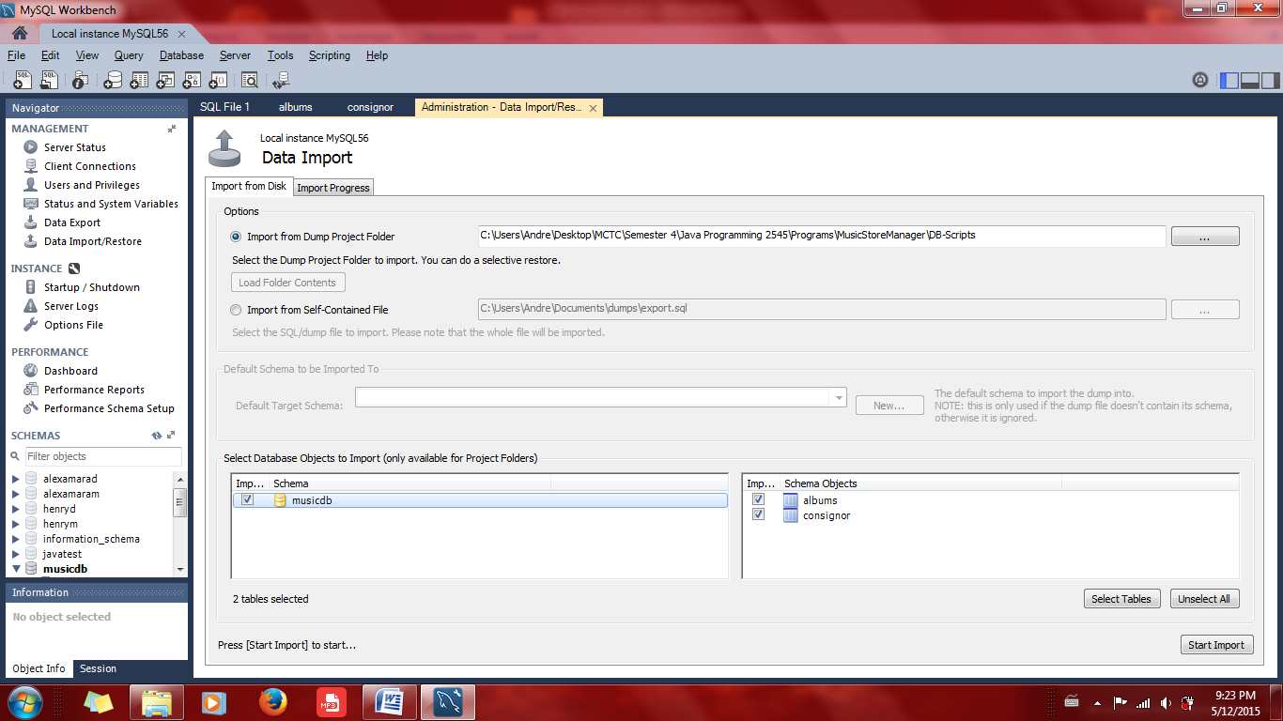

This creates a local schema of the db with all its tables. Then the only thing to do is to create the connection from the program to the local MYSQL server in the programs DB class.

To create a connection, just modify the file in the Project folder called “Login.txt” which should contain the username and password of your local MySQL database location. 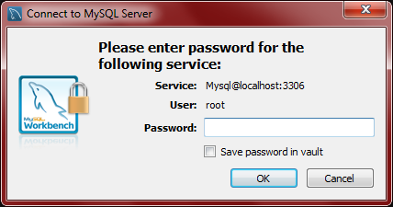

Like this: